**Madan Bhandari Memorial College**

Affiliated to Tribhuvan University

Baneshwor, Kathmandu



**A Software Proposal on**

**“Restaurant Management System”**

**Submitted By Submitted To**

Utshav Poudel Department of CSIT

Aayush Basnet Madan Bhandari Memorial College

Nishcal Kunwar Baneshwor, Kathmandu

**Date:**

**Contents**

Introduction............................................................................................................ 1

Objective................................................................................................................ 2

Workflow Diagram................................................................................................ 3

Proposed System: ................................................................................................. 4

Overview ...................................................................................................4

Actor...........................................................................................................4

Functional Requirements............................................................................5

Non-functional Requirements ...................................................................6

Implementation Requirements...................................................................7

Hardware Requirements: ..........................................................................7

Software Requirements: ............…...........................................................7

Requirement Analysis: ........................................................................................ 8

Use Case Diagram.....................................................................................8

Class Diagram .........................................................................................14

Sequence Diagram...................................................................................16

State Machine Diagram..........................................................................19

Component Diagram .....................……….............................................21

Implementation................................................................................................... 24

Testing................................................................................................................ 30

Future Scope....................................................................................................... 34

Conclusion........................................................................................................... 35

References........................................................................................................... 36

**Introduction**

Efficient management of customer orders, menus, and overall operations is the backbone of any successful restaurant or hostel. With evolving customer expectations, increasing demand, and the need for quick and accurate service, traditional manual methods of order tracking and menu management often fall short. These outdated practices can lead to inefficiencies, errors, and delays, negatively impacting customer satisfaction and overall business performance.

Recognizing these challenges, our project, **“Restaurant Management System,”** is a solution designed to address the pain points of restaurant and hostel operations. This software aims to provide a seamless experience for staff and management by integrating multiple essential features into a single, user-friendly platform.

At its core, the system is built to simplify the process of order handling, menu updates, and real-time performance tracking. By offering real-time analytics, the system empowers restaurant owners and managers to make data-driven decisions, helping them understand their business performance at a glance.

The **Restaurant Management System** consists of several core features, including:

* **Centralized Dashboard:** Provides comprehensive insights such as top-selling items, busiest hours, daily sales, and more, allowing for better business decisions.
* **Dynamic Menu Management:** Enables restaurants to add, edit, or remove menu items instantly.
* **Efficient Order Management:** Tracks and updates order statuses in real time, ensuring accuracy and reducing delays in service.

Our **Restaurant Management System** is designed to be highly adaptable, catering to businesses of all sizes—whether it’s a small hostel or a bustling multi-cuisine restaurant. The system is built using modern technologies, ensuring scalability, reliability, and ease of use. It serves as a vital tool for business owners aiming to thrive in the competitive hospitality industry by staying ahead of the curve.

# **Objective**

1. Simply ordering through table tablets.
2. Track and provide real-time updates on order status.
3. Record sales data; recommend best-selling items and today special items to user.

The primary aim of the **Restaurant Management System** is to modernize and optimize the way restaurants and hostels operate. Traditional methods often involve manual processes, which can lead to errors, delays, and inefficiencies. This software replaces those outdated methods with a centralized digital solution that ensures accuracy and speed.

**Workflow Diagram**

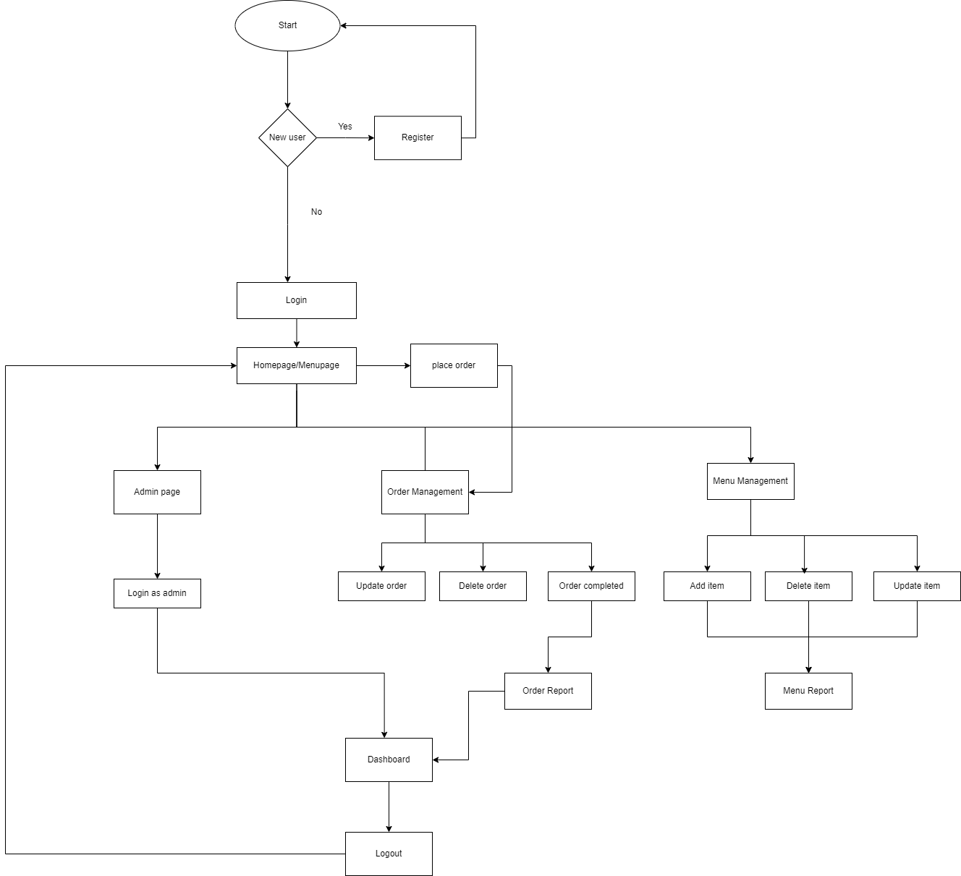

**Overview**

The aim of the **Restaurant Management System** is to simplify and optimize the daily operations of restaurants and hostels by providing a platform for managing orders, menus, and performance analytics. All essential business-related information, such as menu updates, order tracking, and sales performance, are managed through a centralized system. The primary objective is to provide a convenient software solution that streamlines these processes, reducing errors, delays, and inefficiencies associated with traditional manual methods.

The system is designed to be intuitive and user-friendly, allowing administrators, managers, and staff to seamlessly navigate and perform their tasks. It enables administrators/manager to monitor performance metrics such as top-selling items, busiest hours, and total sales, as while dynamically update menus and oversee order statuses. Staff members can input and track customer orders in real-time, ensuring timely and accurate service.

The **Restaurant Management System** is built to work efficiently on a wide range of configurations, ensuring accessibility for businesses of all sizes. Its minimalistic and efficient design ensures low resource consumption while delivering high functionality. In conclusion, the system offers a comprehensive and hassle-free solution for restaurants and hostels, enhancing operational efficiency, improving customer satisfaction, and supporting overall business growth.

**Actor**

Actors represent the external entities that interact with the system. The actors of the Proposed Restaurant Management System are as follow:

* Administrators/Owner/Manager
* Staff (Waiters/Kitchen Team)
* System (Software)

**Functional Requirements**

Functional requirements of a system describe the specific capabilities that the system must possess in order to fulfill its intended purpose. These requirements are typically defined based on the type of software being developed, the system's intended user base, and the overall objectives of the organization.

1. **Order Management**

* The system must allow staff to take customer orders and update order statuses in real time.
* It should support modifying or canceling orders as required.

1. **Menu Management**

* The system must enable administrators and managers to update menu items, prices, and availability dynamically.
* Categories and descriptions of menu items should also be manageable through the system.

1. **Dashboard and Analytics**

* The system should provide a dashboard with detailed analytics, including top-selling items, busiest times, total sales, and customer preferences.

1. **User Authentication and Role Management**

* The system must provide secure login access with role-based authentication for administrators, managers, and staff.
* Each user role should have specific permissions (e.g., admin for system-wide settings, staff for order input).

**Non-Functional Requirements**

Non-functional requirements are specifications that define a system's characteristics unrelated to the services it offers to its users. These requirements set boundaries for the system and may include factors such as its reliability, speed of response, and memory usage. It consists of the

Followings parameters:

1. **Performance**

* The system should process order updates and menu changes without noticeable delay, even during peak hours.

2. **Scalability**

* The system must handle increased orders, users, and menu items as the restaurant or hostel grows.

3. **Security**

* Data, including customer orders and sales reports, should be securely stored and accessed only by authorized users.

4. **Usability**

* The interface should be intuitive and easy to use for all roles, requiring minimal training for staff.

5. **Availability**

* The system must be highly available with minimal downtime to ensure smooth restaurant operations during business hours.

**Implementation Requirements**

**Hardware Requirement**

|  |  |
| --- | --- |
| Processor |  |
| RAM |  |
| Hard Disk Space |  |

**Software Requirement**

|  |  |
| --- | --- |
| Operating System | Windows, MACOS, Linux or any other  platform that supports web browser |
| Database Management System | MySQL |
| Web Server | Apache |
| Client Application | Any Web Browser |

**Requirement Analysis**

Requirement Analysis is an essential process for defining user expectations for new or modified software. It involves determining quantifiable, relevant, and detailed features, referred to as requirements. Communication with system users is a crucial aspect of the process as it helps in identifying specific feature expectations, resolving conflicts or ambiguities in requirements demanded by various users or groups, and avoiding feature creep. Another important aspect of Requirement Analysis is the documentation of all aspects of the project development process from start to finish. The ultimate goal of this process is to produce a model of the system, referred to as the analysis model, which is correct, complete, consistent, and verifiable. The analysis model comprises three individual models:

* + The functional model (represented by use cases and scenarios)
  + The analysis object model (represented by class object diagrams)
  + The dynamic model (represented by state machine and sequence diagrams)

**Use Case Diagram**

A use case diagram is a type of UML (Unified Modeling Language) diagram that is used to visualize and describe the interactions between actors and a system or application. In a Use Case Diagram, use cases are represented as ovals or ellipses, while actors are represented as stick figures. Arrows are used to show the relationships and interactions between actors and use cases. Use Case Diagrams are often used during the analysis and design phase of software development to help identify and clarify the requirements and functionality of the system. They can also be used to communicate the system's functionality to stakeholders, such as developers, designers, project managers, and end-users.

In the Use Case Diagram, we have two primary actors- the customer and the admin. The Login use case allows the Admin actor to log in into Restaurant Management Software. The ‘view menu’ use case allows both actors to view menu to order in Restaurant. The ‘manage menu’ use case allows admin to add/remove items in the system as per demands/season, as well admin can change price of food items as needed. The ‘manage menu’ allows customer/admin to update/insert/delete menu as per customer need and available materials. The ‘Analytics & Report’ use case allows the admin to observe restaurant performance through different charts and dashboard, where they can measure performance and all overall activities of their restaurant.

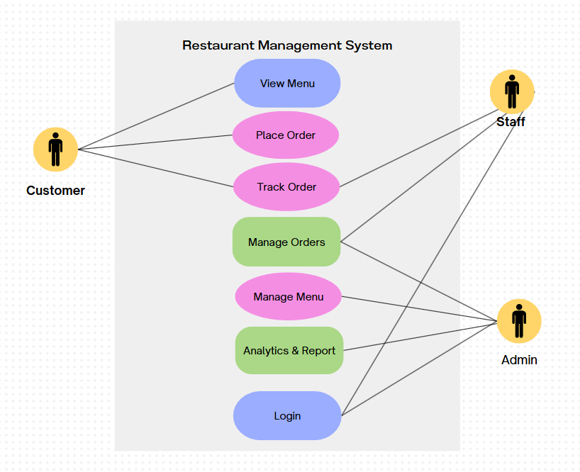

fig: Use Case Diagram

**Actors Involved:**

* 1. Admin (Restaurant Manager/Owner) – Manages the overall system, menu, staff, and reports.
  2. Staff (Waiters/Kitchen Staff) – Takes orders, update order status, and processes payments.
  3. Customer – Places orders, view menu, and provides feedback.

**Class Diagram**

Class diagrams are a graphical representation of the classes, attributes, methods, and relationships within an object-oriented system. They are used to model the structure of a system and show how its components interact with each other. The class diagram consists of several components:

* Class: a blueprint for creating objects that have common attributes and behaviors.
* Attribute: a property or characteristics of a class
* Method: an operation or action that can be performed by a class
* Relationship: a connection or association between two or more classes.

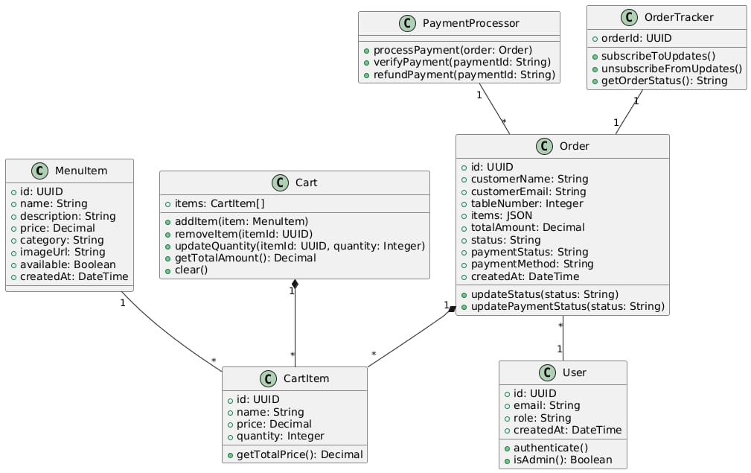

fig: Class Diagram

**Sequence Diagram**

A sequence diagram is a type of interaction diagram that shows the interactions between objects or components in a system over time. It visualizes the flow of messages, requests, and responses between the various objects or components involved in a particular use case or scenario.

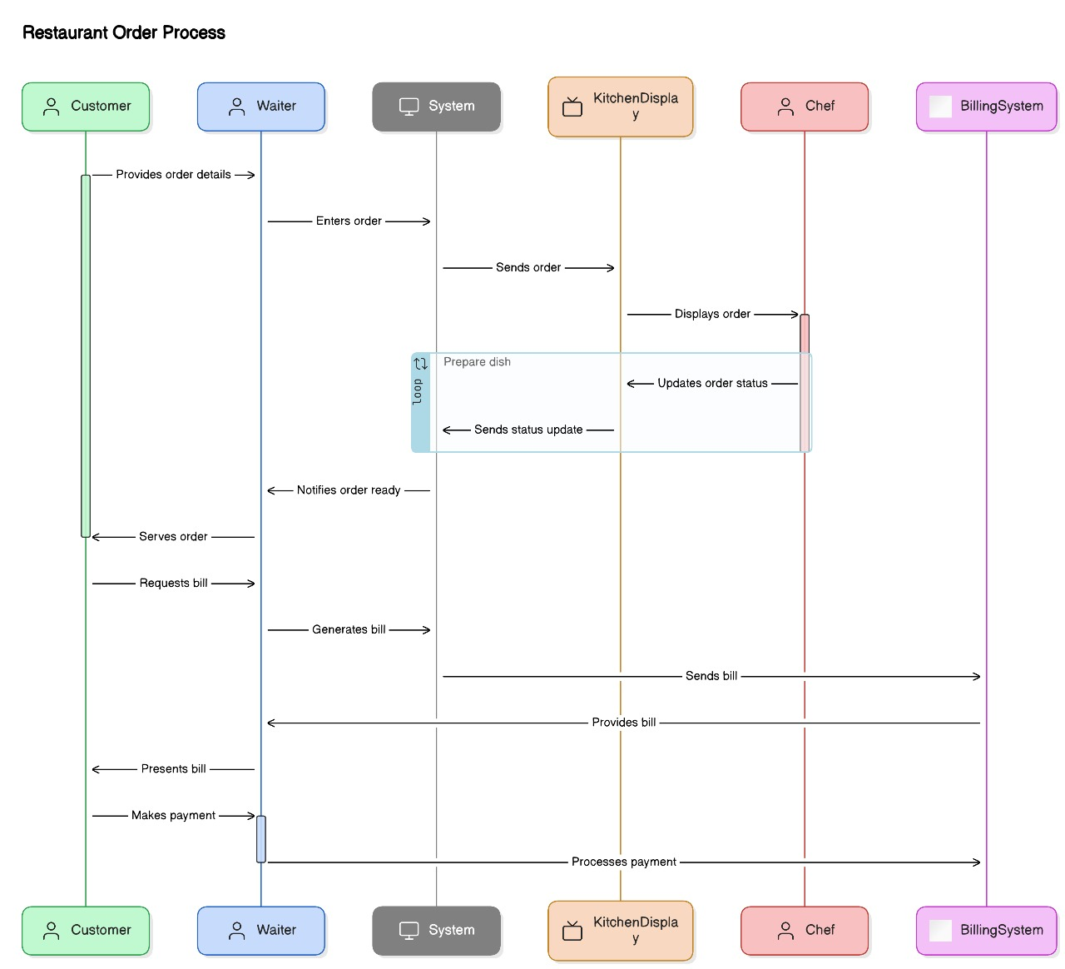

**Activity Diagram**

An Activity Diagram is a way to show how an object changes over time by displaying its different states and how it transitions between them. Each state represents a particular set of values for the object. Transitions show how the object can move from one state to another, and also explain the conditions or reasons for the change in state. In simple terms, state machine diagrams illustrate the different states an object can be in and how it can move from one state to another based on certain conditions.

**Component Diagram**

A component diagram is a type of structural diagram in UML (Unified Modeling Language) used to visualize the components of a system and their relationships. It provides a high-level view of the system's architecture, focusing on the components and their interactions.

**Future Scope**

The future scope of Restaurant Management System can encompass several advancements and improvements. Here are some potential areas of development.

* Integration with Mobile Applications

A mobile app version of the system will allow restaurant staff and managers to access key features, such as order management, menu updates, and performance tracking, from anywhere. This will enhance flexibility and ensure smooth restaurant operations without requiring a desktop.

* Online Table Reservation & Pre-Order System

Customers will be able to reserve tables in advance and pre-order meals through the system. This will help reduce wait times, improve customer experience, and allow restaurants to manage seating and kitchen workflow more efficiently.

* Multi-Branch & Cloud-Based Management

For restaurant chains and hotels with multiple locations, a cloud-based system will enable centralized management of all branches. Owners and managers can monitor sales, inventory, and performance of different locations from a single platform, improving efficiency and decision-making.

* Customer Feedback & Loyalty Program

The system will include customer feedback collection and loyalty programs, such as reward points, discounts or special offers for frequent customers. This will help restaurants improve service quality, retain customers, and build long-term customer relationships.

These enhancements will make the Restaurant Management System more efficient, scalable, and adaptable to future restaurant and hotel industry needs. It’s important to note that the above possibilities provide a glimpse into potential future directions, but the actual trajectory may evolve differently based on various factors.

**Conclusion**

In conclusion, the development and implementation of the Restaurant Management System project have successfully addressed the challenges and limitations of traditional management system. It is designed to modernized restaurant operations, making order processing, menu management, and sales tracking more efficient. By replacing traditional, error-prone manual processes with a digital system, restaurants and hotel can significantly improve accuracy, speed, and overall customer satisfactions.

Throughout the project, key objectives were achieved, including the creation of a seamless and intuitive user interface; simplify the ordering process, and the implementation of advanced features such as dashboard and charts. These advancements have significantly improved user convenience and satisfactions.

While the current version focuses on essential functionalities like order management, menu updates, and performance analysis, the future holds vast potential for enhancements. Cloud-based multi-branch management and customer engagement features such as loyalty programs and personalized offers can transform how restaurants operate in a highly competitive market. Additionally, online reservations and mobile app accessibility will further elevate the system’s usability and efficiency.

The Restaurant Management System project has successfully achieved its objective of providing a convenient, user-friendly, and technologically advance platform for restaurant management process. With continuous improvements and feature expansions, it has the potential to revolutionize restaurant management, making operations smoother, data-driven and highly customer-centric.